Needfinding - Storyboards AND User Journeys
Storyboards Outline
- Storyboarding
  - Storyboarding isn't about "pretty pictures" it's about communicating ideas
  - Simple visual can show a lot
  - Storyboards Should Convey
  - Setting
    - People involved
    - Environment
    - Task being accomplished
  - Sequence
    - What steps are involved?
    - What leads someone to use the app?
    - What task is being illustrated?
  - Satisfaction
    - What motivates people to use this system?
    - What does it enable people to accomplish?
    - What need does the system fill?
  - Benefits of Storyboarding
    - Holistic focus: Helps emphasize how an interface accomplishes a task
    - Avoids commitment to a particular user interface (no buttons yet)
    - He|ps get all the stakeholders on the same page in terms of the goal
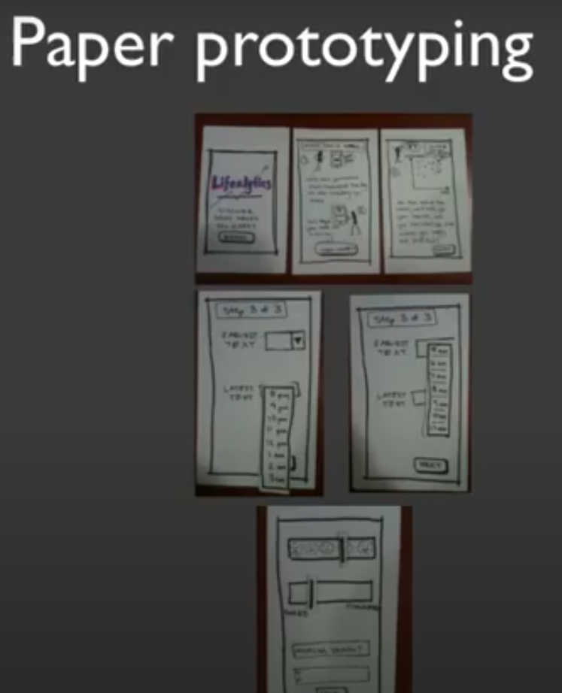
  - Time Limits Help
- Creating Paper Prototypes
  - Make mock-up of user interface on paper
  - 6 Paper Prototyping Tips & Tricks
    - Keep all your materials in one place! Small interface widgets tend to get lost or damaged easily
    - Work quickly and make reusable components (buttons. etc)
    - If something is difficult to simulate (progress indicators. right mouse menus. hyperlinks). have the user ask if it is available and then verbally describe the interaction
    - Backgrounds (I l"xl4" poster board) can be useful to contain the prototype and provide context for the user
    - Don't be afraid to mix and match hardware and software! for instance. if size constraints are important. you might want to make a blinder using a photograph of the device that would be used and manipulate the prototype within the frame
    - When appropriate. add conteXt by including familiar operating system elements
  - Get Creative with Materials
    - Widgets: Paper, Cardboard,Transparencies
    - Connectors:Tape, Glue, Rubber Cement
    - Drawing: Pens, Pencils, Markers
    - Poster board, unlined index cards and foam core are all useful depending on the size of your prototype
    - Removable tape or restickable glue is useful for changing components quickly
    - Transparency pens allow the user to input content - use a sheet of transparency paper for the input field
    - Use wide-tipped pens and markers (think Sharpie) - smaller line widths can be difficult to see
    - Use stacks of index cards to simulate tabbed dialog boxes
- Testing Paper Prototypes
  - Test multiple prototypes simultaneously get most value
  - Get users (and other stakeholders) to help design. Scaffold their efforts
- Digital Mock-ups
- 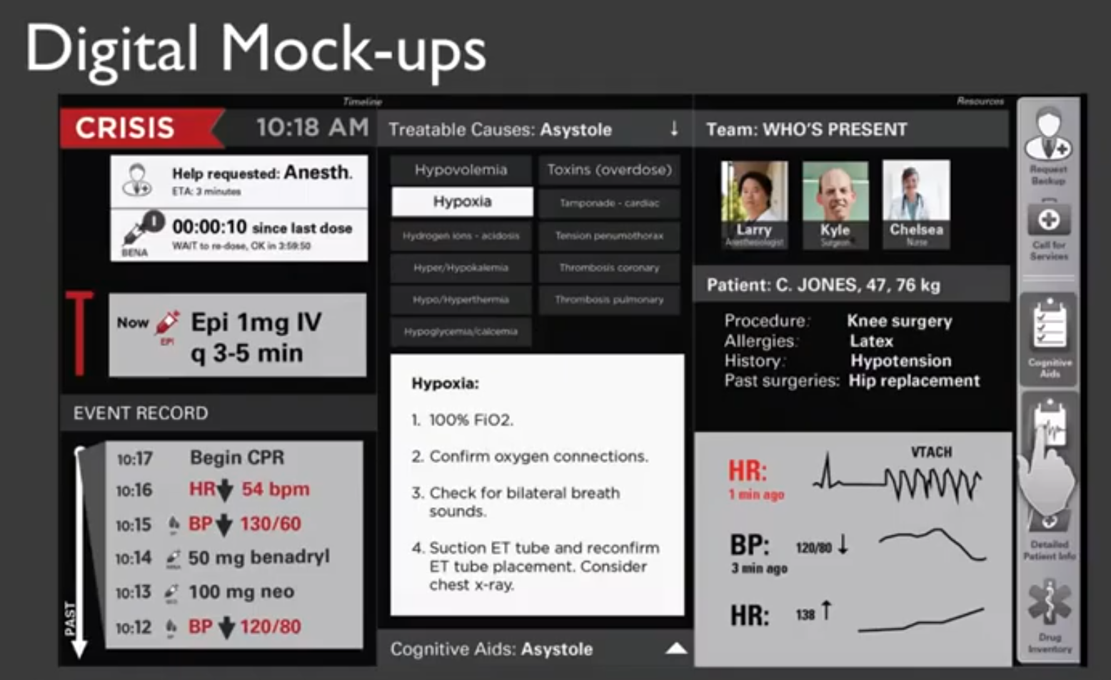

User Journey Outline

A user journey is a series of steps which represent a scenario in which a user might interact with the thing you are designing. They should always be based on research and data.
They can be used for 2 main things:
- Demonstrating the way users currently interact with the service or product
- Demonstrating the way users could interact with the service or product
- There are many benefits to investing time into user journeys:
- Demonstrating the vision for the project - user journeys are a great way to communicate what you are trying to achieve with stakeholders.
- They help us understand user behavior - User journeys can help you work out how users are going to interact with your system and what they expect from it.
- They help identify possible functionality at a high level - by understanding the key tasks
- They help you define your taxonomy and interface - understanding the ‘flow’ of the various tasks the user will want to undertake
User journeys typically come towards the beginning of a project in the discovery or requirements gathering phase. This is both to visualize the user requirements and help feed into other design activities such as information architecture or wireframing.
User Journey needs
- Your user’s goals
- Their motivations
- Their current pain points
- Their overall character
- The main tasks they want to achieve
User journey map and customer journey map means the same thing
- It is a visualization that tells a narrative of the end user trying to accomplish a specific task or goal as it pertains to your company.
- All journey maps look different, but 5 underlying components are in all of them.
- The first is the actor.
- Second, we're going to breathe life into the actor with a scenario and expectations.
- Third is journey phases - These are high-level, meaningful chunks of information that tell that high-level narrative of what your user is doing.
- Fourth is - our actions, mindsets, and emotions.
- Then the last but most important component are insights and opportunities.
- 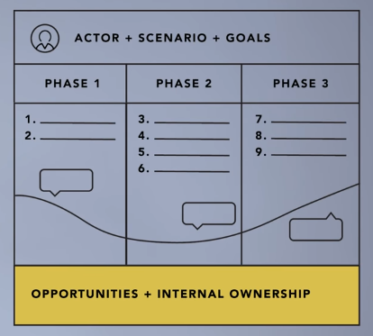
- Customer journey maps have two huge benefits, as does any qualitative process I talk about.
- The first being the benefits from doing it with others. You create that shared language, that shared understanding, the same mental model of what your end user is doing.
- Now, done well, that process then creates this artifact. That's the second benefit.

